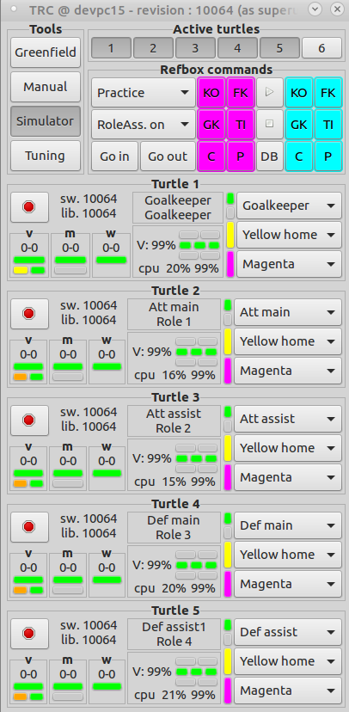
Refbox commands
- Commands per team (Cyan and Magenta):
- Kick off (Cyan and Magenta)
- Free kick (Cyan and Magenta)
- Goal kick (Cyan and Magenta)
- Throw in (Cyan and Magenta)
- Corner (Cyan and Magenta)
- Penalty (Cyan and Magenta)
- Commands common:
- Dropped ball
- Start
- Stop
- Go in
- Go out

- Configuration dropdowns
- Role assigner mode (dropdown)
- Role assigner on
- Role assigner off
- Pass demo
- Penalty mode
- Ball handling demo

- Commands per robot
- Start software (button)
- Role (dropdown)
- Inactive
- Role None
- Goalkeeper
- Attacker main
- Attacker assist
- Defender main
- Defender assist
- Defender assist 2
- Home goal (dropdown)
- Yellow
- Blue
- Team (dropdown)
- Cyan
- Magenta

IF Ballhandling demo is selected, the role dropdowns have to be replaced by an togglebutton (active/inactive)

IF penalty mode is selected, the refbox commands per team have to be replaced by three buttons per team named : Soft, Medium, Hard.

The togglebuttons on top of the trc can be used to select which turtles appear in the bottom.

At startup, the home goal and team color should have the default Yellow home and Magenta team. The default role at startup should be Inactive.

